Name
Scaffold

Table of Contents
Section 1 - Identifying and Defining (20 Marks) 2
1.1 — Client Scenario 3
1.2 — Environmental Specification 3
1.3 — List of Objectives 5
1.4 — Performance Criteria 7
1.5 — IPO (Input-Process-Output) 8
1.6 — Gantt Chart 9
Milestone 1: This should be completed by: Term 1 – Week 3 11
Section 2 - Research and Planning (30 Marks) 11
2.1 — Research 12
2.2 — Data Flow Diagram (DFD) 12
2.3 — Storyboard 16
2.4 — Pseudocode 18
Milestone 2: This should be completed by: Term 1 – Week 6 19

Section 1 - Identifying and Defining (20 Marks)

— Client Scenario
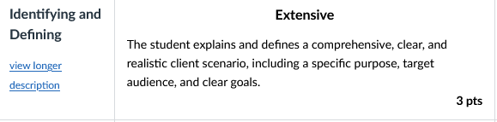
Define a clear scenario based on the client’s needs, including the application’s purpose, target audience, and primary goals. Detail the client's requirements and provide a narrative that encapsulates the problem that the application aims to solve. Explain the overall vision and the expected impact of the application.

Verb:
- Define: State meaning and identify essential qualities.
- Explain: Relate cause and effect; Make the relationships between things evident; provide why and/or how
Answer:
Purpose: The need is to make a service that automates the process of logging their hours as a learner driver as well as the hardware of the automated plate flipping.

Target Audience: Learner drivers and their fully licensed drivers, so therefore meet the accessibility requirements of having a driver's license.

Primary goals: The primary goal is to make a app/website that integrates with physical L plates, logs hours, and provides you with data analytics.

The story: Currently learner drivers often break the law by not filling their log books correctly out of laziness. Because the process takes 3 minutes to fill in but they are under pressure skip it, especially when parents are running late. You might even forget (intentionally or not) to put the L plates on. This is bad because it results in less qualified and capable drivers on the road. My MDP will solve this by making this whole process more efficient with my the app and compatible hardware. The process of logging a drive should take very minimal time to complete; therefor, the logbook will always be filled in. The client's workflow should be to open their phone and press start, maybe indicate who the supervising driver is and then at the end, press stop or it will automatically stop when out of Bluetooth range.

ADD ADVANCED FETURES
Add in the envromeintal specs and the mobilse pne server HARDHERE ESP

1.2 — Environmental Specification
Outline the technical environment in which the application will operate. This includes hardware, software, network specifications, and other relevant environmental factors. Describe the operating systems, development tools, servers, and other infrastructure components necessary for the application.

Verb:
- Outline: Sketch in general terms; indicate the main features of.
- Describe: Provide characteristics and features

Example:
Image | Part | Specification
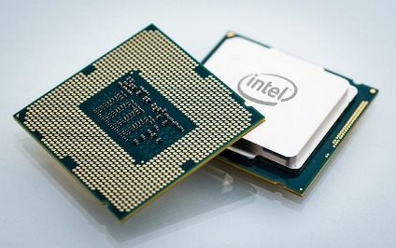 | Central Processing unit | - Multi-thread capable  - Security vulnerability mitigations enabled  - AVX and SIMD instructions
 | Microsoft Sequel server | - Relational database  - Able to store large datasets  - Able to query large datasets quickly

— Environmental Specification
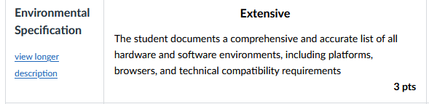
Outline the technical environment in which the application will operate. This includes
hardware, software, network specifications, and other relevant environmental factors.
Describe the operating systems, development tools, servers, and other infrastructure
components necessary for the application.
Verb:
- Outline: Sketch in general terms; indicate the main features of.
- Describe: Provide characteristics and features
Hardware
PUT IN UR LAPTOP
Image | Part | Specification
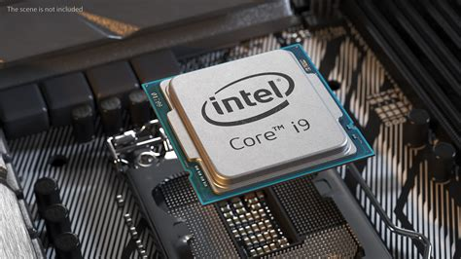 | CPU central processing unit - i9 13900K Processor | - X86
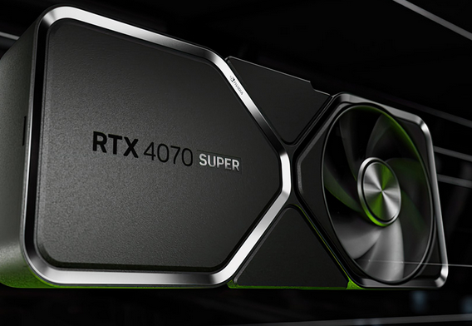 | GeForce RTX 4070 Family | - CUDA Toolkit  - TensorRT  - NVIDIA drivers

Software
Image | Platform | Specification
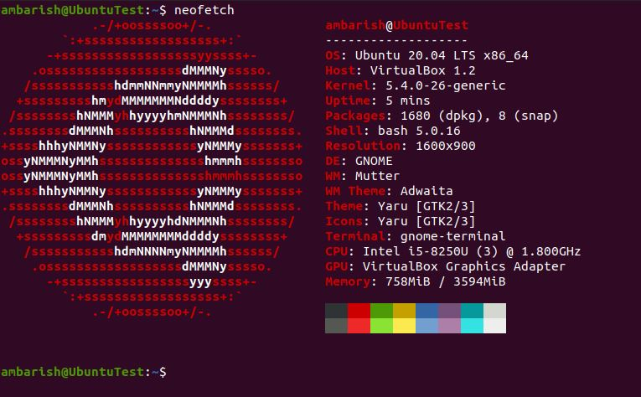 | Ubuntu 20.04 LTS (Linux Server) | Linux Kernel 5.4+  widely compatible
 | Google chrome
 | Mozilla Firefox
 | Platform IO
 | Draw IO
 | ngrok | This lets me serve my website as https for testing

Network
Image | Part | Specification

— List of Objectives
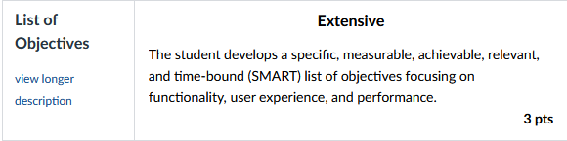
Enumerate the specific objectives that the application aims to achieve. These should be clear, measurable goals that directly address the client’s needs. The objectives could include functionality, user engagement, performance targets, and other relevant criteria.
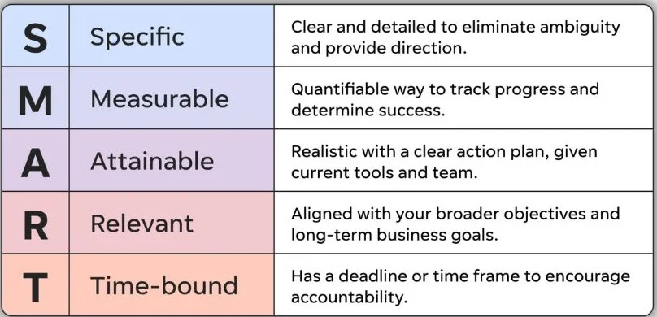

Functional Features:
Feature | Priority 1-10 | Description
- Login | High | Provide the user the ability to use pre-saved credentials to access protected areas of the system
1.1 - Login window | High | Provide users with a screen which allows them to authenticate with the program.  If a user tries to access a restricted location, redirect them to the login
1.2 - Username | High | User can create a unique username  Must provide username at login  If not found prompt user to sign-up
1.3- password | High | User uses a password which to authenticate their account  Password must be 8 characters and contain numbers and symbols
2 – Data logs from the plate | High | This data is saved from onboard sensors and then transmit up to the cloud database
2.1 – Accelerometer data | 7 | This data will be saved at a rate that will be determined later and then sent up to the cloud. The purpose of this data is so that it is help provide analytics the user about driving style on things like breaking or acceleration.
2.2 – GPS data | 10 | This is absolutely essential because this data is the way that the odometer is determined and also the trip distance.
2.3 – speed data (extrapolated from GPS in backend) | 6 | This is data that tracks the speed in the vehicle also provides analytics on if you were speeding* this is a potential feature that might not be technically feasible to get if speeding
plate battery data | 6 | Data on if the L plate is low on battery so that it can be charged
starting drive | 10 | This must be really easy thing to do it must take under 10 seconds, it must also work off line
stopping drive | 10 | This must be really easy thing to do it must take under 10 seconds, it must also work off line
parent approving the drive | 9 | A parent/supervising driver must be able to approve a drive easily
viewing the drives and being able to fill in the log book from that | 10 | The ability to view the logs in a format that is easy to transcribe in to the physical log book.
CRUD the trips | 8 | the user should be able to do different CRUD actions depending on there role
RBA | 8 | The parents should be able to approve and deny drives as well as be able to track there kids progress
Default Settings | 10 | This app must have good default settings to make it secure as it has sensitive data on it like the name, location data, and drivers licence ID
Chatbot | 8 | This chatbot will have rag and be able to answer questions on the laws of driving
PWA Implementation | 10 | The pwa implemsentation is mandatory for offline use

Non-Functional Features
Feature | Priority | Description

Example:
Feature | Priority | Description
- Login | High | Provide the user the ability to use pre-saved credentials to access protected areas of the system
1.1 - Login window | High | Provide users with a screen which allows them to authenticate with the program.  If a user tries to access a restricted location, redirect them to the login
1.2 - Username | High | User can create a unique username  Must provide username at login  If not found prompt user to sign-up
1.3- password | High | User uses a password which to authenticate their account  Password must be 8 characters and contain numbers and symbols

Functional Features: must have

Feature | Priority on a scale 1-10 | Description
Login | 9
RBA parent and student | 8
Password | 9
Username | 9
Log a drive | 10
See your drive history | 10
Parents approve on app | 6
Have default drivers | 7

Non-Functional Features: nice to have
Feature | Priority | Description
Work off line | 4 | Australia does not have mobile data for the whole country so the l plate system must be able to work off line.
Work on iOS, Android, Windows, mac luinx(desktop) | 8 | The logging is done on a phone and the viewing of hours is done on a laptop or phone
Have 99.00% uptime | 7 | Since the app can work off line for the primary role (logging driving) some minimal downtime is permissible because all they happens they can't view their logbook so if late at night, then the down time is not a problem

1.4 — Performance Criteria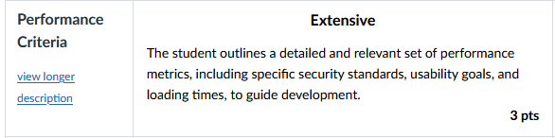
Describe the application's performance criteria, including speed, reliability, scalability, and user satisfaction benchmarks. Define how performance will be measured and the application's standards.
Verb:
- Describe: Provide characteristics and features.
- Define: State meaning and identify essential qualities
Example:
The application must load the main dashboard within 3 seconds for 95% of users under normal operating conditions. System uptime should exceed 99.5% monthly, and the system must support at least 1,000 concurrent users without a noticeable decrease in response time. User satisfaction will be measured through post-launch surveys and should average at least 4 out of 5 stars.

Answer:
- The logging panel should load in 500 ms for a user on mobile data (I might host it in an ESP32 32 in the car and then the ESP32 will act a a buffer)
- The time from first opening the website/PWA to staring the logging should be on average 15 seconds
- The infrastructure should support 200 people starting logging and 2000 people sending drive updates and 500 people viewing their history but have the ability to scale
- The uptime of the main website should be 99.00%
- User satisfaction will be measured by consistency if the user uses the app for the full 100 hours, then that is a win but if the user only logs 1 drive, then I know that there is room for improvement
Improve formatting but the ider is good
Table critatira and tool standard

— IPO (Input-Process-Output)
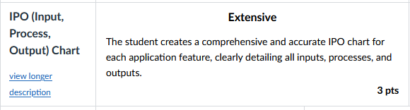
Develop an IPO (Input-Process-Output) chart for the application that clearly outlines the scope of each stage. In your response, specify the types of data and information that users will provide as inputs, detail the system processes—including validation, transformation, and any business logic—that act upon those inputs, and define the expected outputs or results delivered to users. The IPO chart should cover multiple user scenarios, such as account authentication, content submission, and data retrieval, illustrating how user actions are handled by the system from start to finish.

Example:
Input | Process | Output
User login credentials (username, password) | System verifies credentials against database | Access granted or denied message
User uploads image | System checks file type and size, stores image | Confirmation of successful upload
Search query | System processes query and retrieves matching results | List of relevant results displayed

Answer:
Input | Process | Output
Start logging drive
Stop logging drive

— Gantt Chart
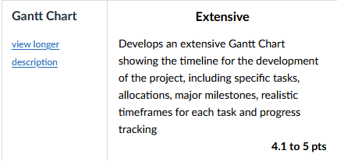
Create a Gantt chart to outline the project timeline. The chart should include all major milestones, tasks, and deadlines. It should also visually represent the project schedule, showing each task's start and end dates and the dependencies between tasks.s

Please note that this is not realistic for a normal but because I am on holiday, I have time and since IT is my only assignment released, I wanted to get a good chunk of it done.
Add couler to the gray bitys break it up
do week a and b and colour code them
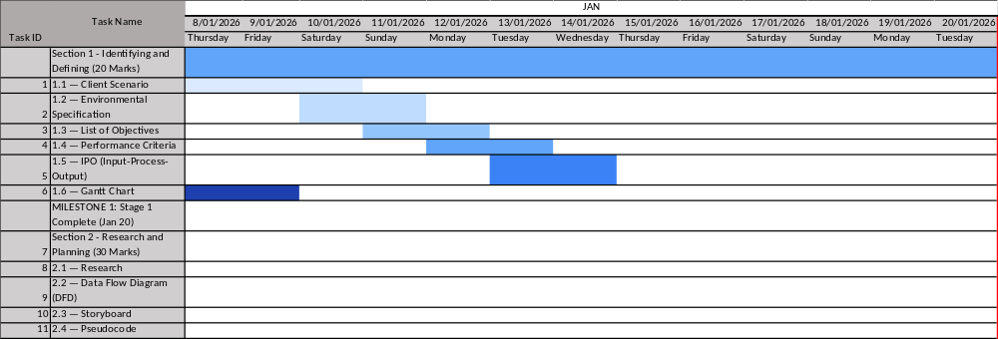
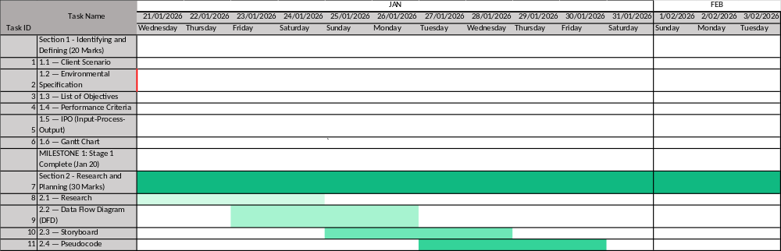

Example:
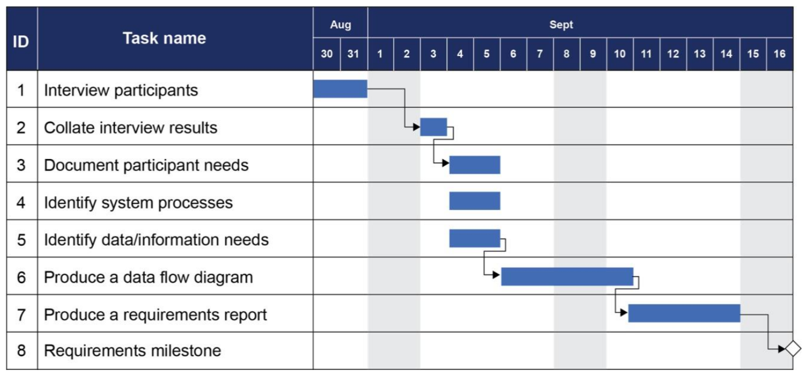

Answer:
Paste a link to your excel Gantt chart (save in OneDrive)

Milestone 1: This should be completed by: Term 1 – Week 3

Section 2 - Research and Planning (30 Marks)

2.1 — Research
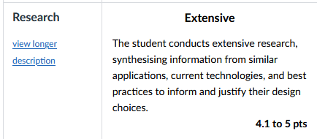
Conduct thorough research to gather information relevant to the project. This should include market analysis, user research, competitor analysis, and other pertinent data. Summarise the findings and explain how they will inform the project’s development.

Verb:
- Summarise: Express, concisely, the relevant details

Answer:
https://www.youtube.com/watch?v=sFsRylCQblw
chrome lighthouse
Look at work box
https://hnpwa.com/ this is a website to help you pick a pwa framework
https://web.dev/
https://web.dev/learn/pwa/welcome?continue=https%3A%2F%2Fweb.dev%2Flearn%2Fpwa%23article-https%3A%2F%2Fweb.dev%2Flearn%2Fpwa%2Fwelcome
need to learn how to get the service worker to work
Web app
Esp 32 server:
First I wrote some very high level pseudo code for how I wanted the app to work. This helped me identify what liberties I needed.
- A database (or some way of storing tabula data)
- Ability to broadcast a wifi network
- Ability to connect to a wifi network and to send data to a cloud server
- Ability to pass and make json
- Ability to read a gps value
- Ability to read a accelerometer value

I chose the following library because of there ease of use and because thay are common choices for the problems I faced.
- WiFi.h
- ESPAsyncWebServerHTTP
- ArduinoJsonJSON
- LittleFSLocal
- HTTPClientSend
To lean about how to use them I asked Haiku 4.5 model to make me a list of the relevant docs and helpful tutorials I gave me the following list
“””
ESP32-C3 Drone Data Logger Project - Library Documentation
Core Libraries & Documentation
1. WiFi.h (Built-in ESP32 Core)
- Official Documentation: https://docs.espressif.com/projects/esp-idf/en/latest/esp32c3/api-reference/network/esp_wifi.html
- Arduino WiFi Reference: https://www.arduino.cc/reference/en/libraries/wifi/
2. ESPAsyncWebServer
- GitHub Repository: https://github.com/me-no-dev/ESPAsyncWebServer
- Documentation: https://github.com/me-no-dev/ESPAsyncWebServer/wiki
- Installation Guide: https://randomnerdtutorials.com/esp32-async-web-server/
3. ArduinoJson
- Official Site: https://arduinojson.org/
- Documentation: https://arduinojson.org/v6/api/
- Quick Start: https://arduinojson.org/v6/getting-started/
4. LittleFS (File System)
- ESP32 LittleFS Documentation: https://github.com/lorol/LITTLEFS
- Tutorial: https://randomnerdtutorials.com/esp32-littlefs/
5. HTTPClient (for sending POST requests)
- Arduino HTTPClient Docs: https://www.arduino.cc/reference/en/libraries/httpclient/
- ESP32 Guide: https://randomnerdtutorials.com/esp32-http-post-request/
6. Preferences.h (Built-in - Persistent Storage)
- Official Documentation: https://docs.espressif.com/projects/esp-idf/en/latest/esp32c3/api-reference/storage/nvs_flash.html
- Arduino Preferences Library Guide: https://randomnerdtutorials.com/esp32-preferences-library/
- GitHub (esp32 core): https://github.com/espressif/arduino-esp32/blob/master/libraries/Preferences/src/Preferences.h
7. Time Management
- Time.h Reference: https://www.arduino.cc/reference/en/libraries/time/
- millis() and micros(): https://www.arduino.cc/reference/en/language/functions/time/millis/
For Analog Pin Reading (GPS/Accelerometer Simulation)
- ADC Reading: https://docs.espressif.com/projects/esp-idf/en/latest/esp32c3/api-reference/peripherals/adc.html
- Arduino analogRead(): https://www.arduino.cc/reference/en/language/functions/analog-io/analogread/
“””
I looked at the demos that the wifi libery provides and saw “simple web serve” by Tom Igoe this is a simple web server I used the code example to make a start_ap() function
https://github.com/espressif/arduino-esp32/blob/master/libraries/SD/examples/SD_Test/SD_Test.ino how to wirght to a sd card

L plate hardwear:

THE PWA:
https://www.youtube.com/watch?v=L5O8uyX2cU8 looking at best web stacks

broke down choosing a tech stack
There is no one best tech stack, but there is a best tech stack for you and to determine it asses it with these following things.
https://www.youtube.com/watch?v=R5BwFCyV9Mk
What is a tech stack
Learning Curve
Ecosystem
Compatibility & Interoperability
Performance and Cost
Team Expertise
Future-proofing

I have now decided to use flask as I am very similar with python and I don’t need performance it has a bigger enough ecosystem

PWA stuff
https://blog.appmysite.com/what-is-a-progressive-web-app/
https://www.youtube.com/watch?v=wQgx5Pou44s
https://web.dev/learn/pwa
https://hnpwa.com/
https://developer.mozilla.org/en-US/docs/Web/Progressive_web_apps/Tutorials
https://www.youtube.com/watch?v=sFsRylCQblw Progressive Web Apps in 100 Seconds // Build a PWA from Scratch : Fireship
https://developer.chrome.com/docs/workbox/
https://github.com/elegantapp/pwa-asset-generator
HOW TO COMMUNICATE TO THE ESP 32
https://stackoverflow.com/questions/53211319/how-can-i-make-an-http-request-from-an-https-website my fist idea was to have the esp 32 host a server that acts as a API endpoint but this can’t work because mixed content (having https and http) is unsafe so I need to find a way around that.

2.2 — Data Flow Diagram (DFD)
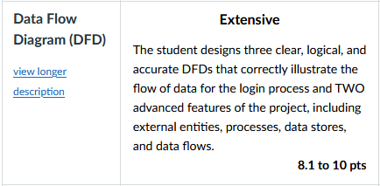
Design a DFD for each feature of your project to illustrate how data will flow through the system. The DFD should show the interactions between inputs, processes, and outputs. Provide detailed diagrams and explanations for each feature. 1 DFD should represent the login aspect of your system.
Symbols:
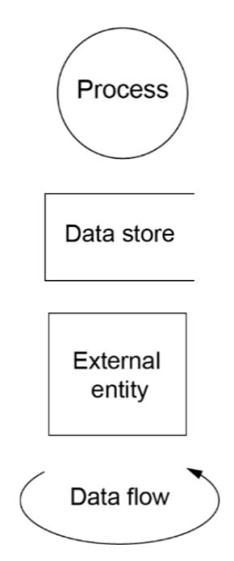
- Process, turns inputs into outputs
- External entity represents any person, organisation or element which provides/receives data from external to the system
- Data store can be electronic or physical storage of information.
- Dataflow is a curved arrow that represents the exchange of data between elements of a data flow diagram
Example:
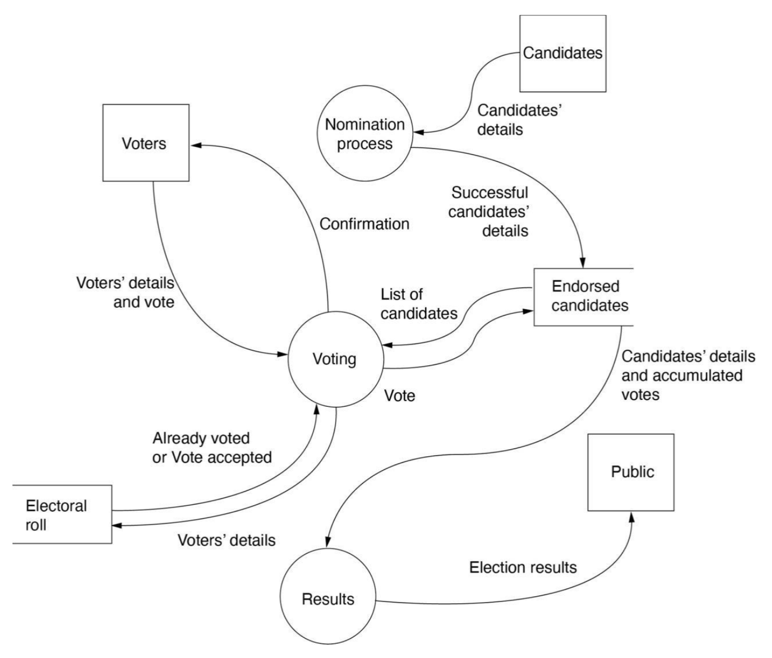

Answer:
DFD 1
Screenshot of DFD1:

Link to DFD1 in OneDrive:

DFD 2
Screenshot of DFD1:

Link to DFD1 in OneDrive:

DFD 3
Screenshot of DFD1:

Link to DFD1 in OneDrive:

2.3 — Storyboard
Use figma or adoby xd
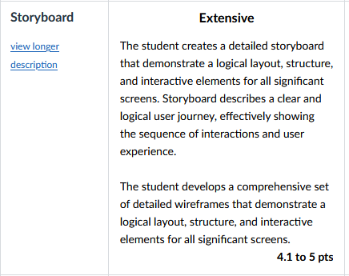
Create a storyboard to visually represent the application's layout and design. Include annotations and explanations for each element of the interface. The storyboard should also outline the user journey through the application. It should include key screens, user actions, and interactions. Provide a narrative to explain how users will navigate the application and achieve their goals.

Example:
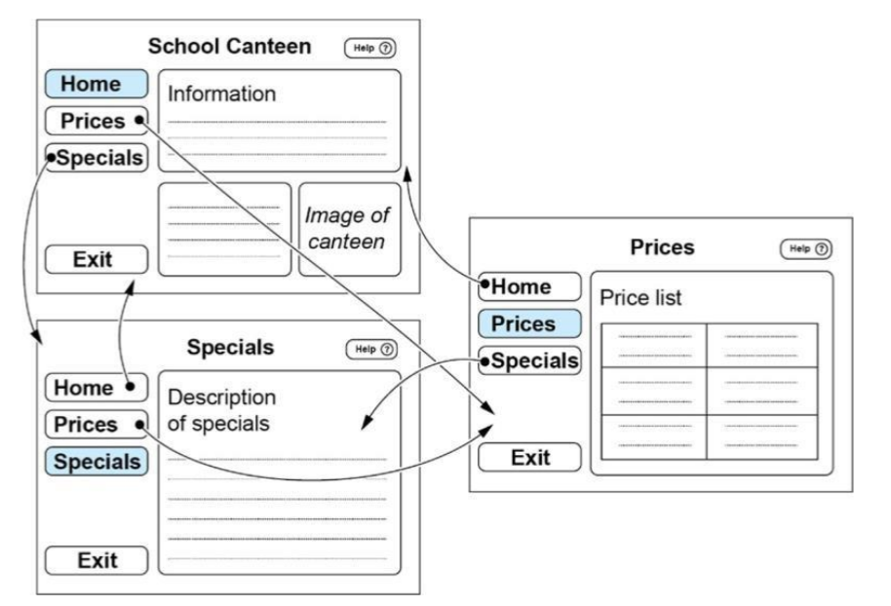

Answer:
Screenshot of Storyboard:

Link to Storyboard in OneDrive:

2.4 — Pseudocode
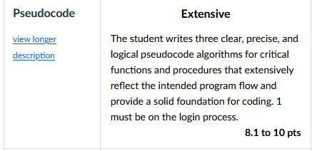
Write three pseudocode algorithms for critical functions and algorithms in the web application's backend. These pseudocode algorithms should provide a clear foundation for coding the application. Include detailed explanations and comments for each algorithm. 1 of these algorithms should represent the login function of your web-application.

Example:
BEGIN read(Array_name)
SET pointer to first position
GET a character
WHILE more data AND space in array
Store data in Array_name at the position given by the pointer
INREMENT the pointer
GET the next Character
ENDWHILE
END read(Array_name)

Answer:
Algorithm 1

Algorithm 2

Algorithm 3

Milestone 2: This should be completed by: Term 1 – Week 6

